# Correlated Subquery with Multiple Conditions

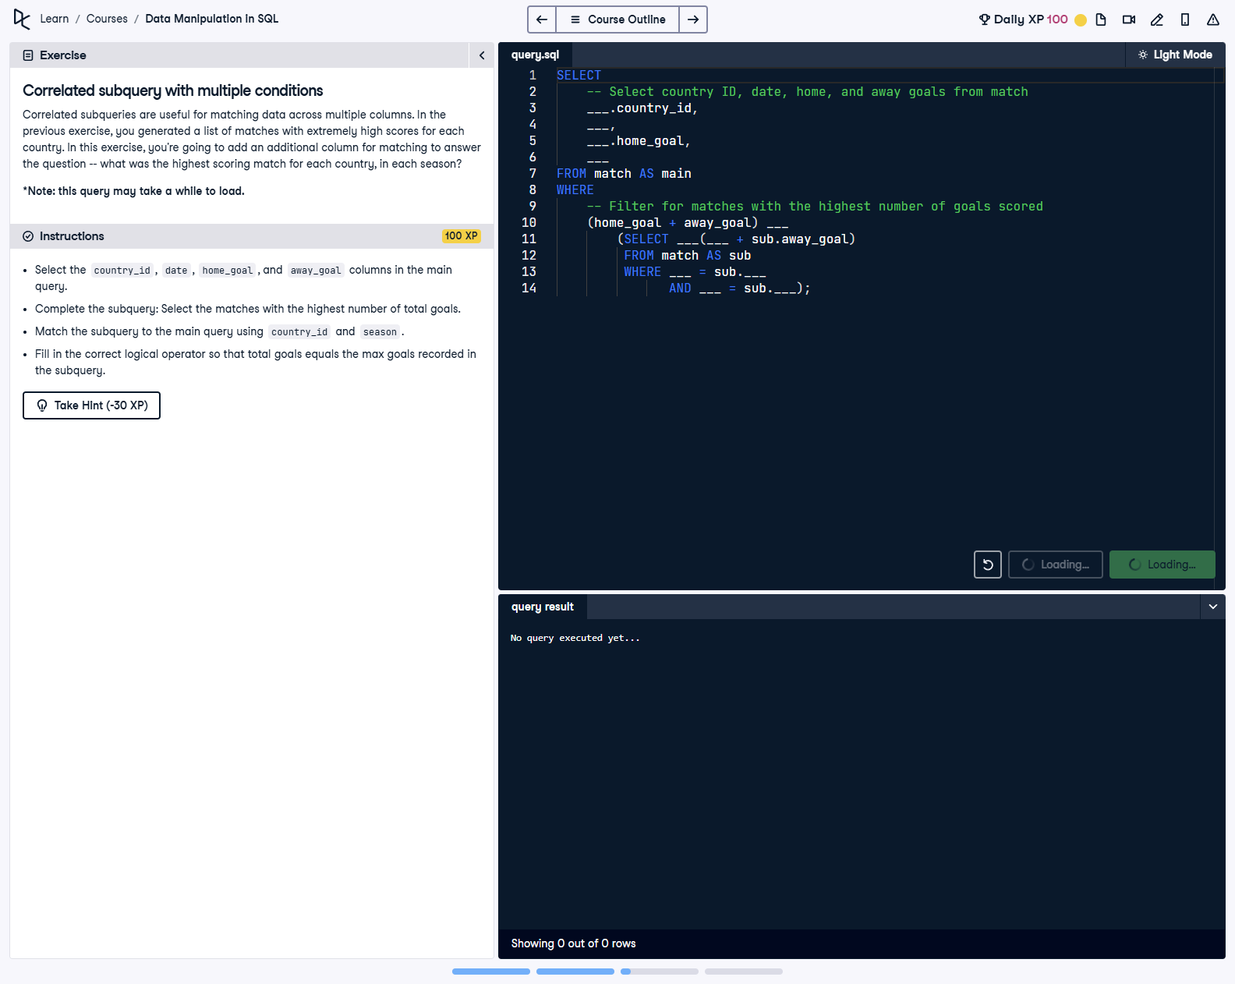

## Question

1. Select the country_id, date, home_goal, and away_goal columns in the main query.  
  
2. Complete the subquery: Select the matches with the highest number of total goals.  
  
3. Match the subquery to the main query using country_id and season.  
  
4. Fill in the correct logical operator so that total goals equals the max goals recorded in the subquery.

## Corrected Solution

SELECT  
 -- Select country ID, date, home, and away goals from match  
 main.country_id,  
 main.date,  
 main.home_goal,  
 main.away_goal  
FROM match AS main  
WHERE  
 -- Filter for matches with the highest number of goals scored  
 (main.home_goal + main.away_goal) =  
 (SELECT MAX(sub.home_goal + sub.away_goal)  
 FROM match AS sub  
 WHERE main.country_id = sub.country_id  
 AND main.season = sub.season);

## Explanation

This query retrieves the matches with the highest number of total goals scored (home + away goals) for each country and season. The subquery calculates the maximum total goals for each combination of country_id and season. The WHERE clause in the main query ensures that only matches with total goals equal to this maximum are included in the result.